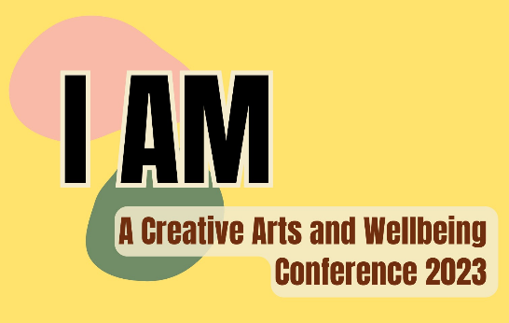
Creative Arts and Wellbeing Conference
Application Form

Personal Information:
Name: __________________________________________________________
Date of Birth: _____________________________________________________
Gender: _________________________________________________________
Nationality: ______________________________________________________
Address: _________________________________________________________
_________________________________________________________
Postal Code: ______________________________________________________
Email Address: ____________________________________________________
Phone Number:____________________________________________________

Next of Kin/Emergency Contact:
Contact Name: ____________________________________________________
Relationship to Attendee: ____________________________________________
Phone Number: ____________________________________________________
Email Address: _____________________________________________________

If you were to describe yourself as a song title, what would that title be?
__________________________________________________________________

Declaration: By submitting this application, I acknowledge that I have read and understood the conference information sheet. I also understand that participation in the conference is voluntary, and I release the organizers and staff from any liability for injury, loss, or damage incurred during the event.
Signature: ____________________________________
Date: ____________________________________

Send this completed form to info@spieelcollective.co.za
For more information contact Nolan Africa at 079 581 1939

